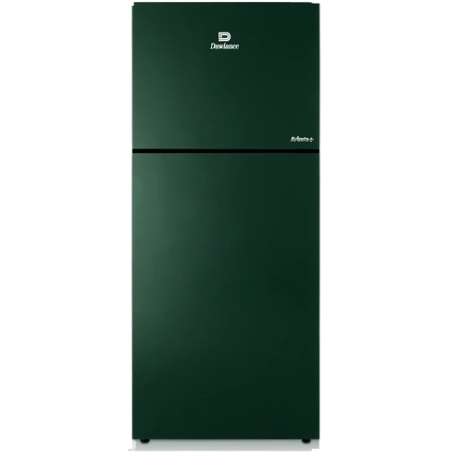**Liberty Electronics**

# Dawlance Refrigerator 9191WB Avante Plus

**₨114,999**

Vendor: [Dawlance](https://bakar.pk/collections/all?filter.p.vendor=dawlance)

Product Type: [Double Door - Direct Cool](https://bakar.pk/collections/all?filter.p.product_type=double+door+-+direct+cool)

Barcode: 28.01.273.0005

Top of Form

Bottom of Form